NAME___________________________________DATE________________

ALGEBRA II WORKSHEET ON FUNCTION GRAPHS

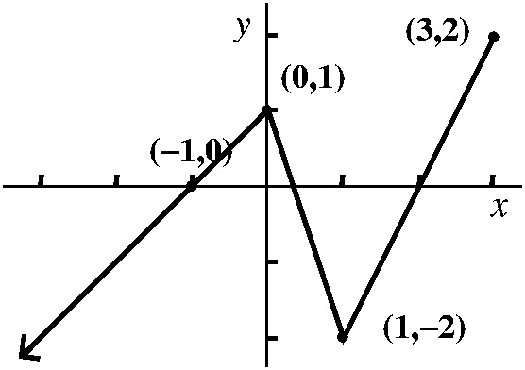The graph of f(x) is shown below. Use it to answer the following questions.

1. State the intervals on which the function is increasing.

2. State the intervals on which the function is decreasing.

3. State the intervals on which the function is constant.

4. Write any relative extrema for the function. Include whether they are relative maxima or minima and the values of x at which they occur.

Use the set of axes to graph each of the following.

5.  6. 

7.  8. 

9.  10. 

11. 