NAME_________________________________________________DATE____________________________

ALGEBRA II WORKSHEET ON TRANSFORMATIONS

Use knowledge of parent functions and transformations to graph each function on the axes provided.

1.  2. 

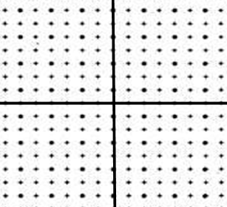

3.  4. 



5.  6. 



7.  8. 

9. 

