NAME___________________________________DATE___________________
ALGEBRA II PRACTICE: GRAPHS OF FUNCTIONS

Refer to the graph to answer the following questions about the function f(x).

PART A. As x approaches negative infinity, f(x) reaches a lower bound of -1. Each increment represents one unit.

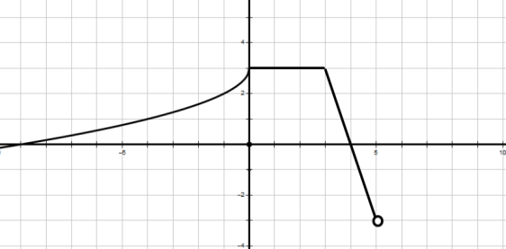
1. What is the domain of the function?

2. What is the range of f(x)?

3. On what interval(s) is the function increasing?

4. On what interval(s) is the function decreasing?

5. On what interval(s) is the function constant?

6. On what interval(s) is f(x) positive?

6. What is the y-intercept of the function?

7. What are the x-intercepts of the function?

8. What are the zeroes of f(x)?

PART B
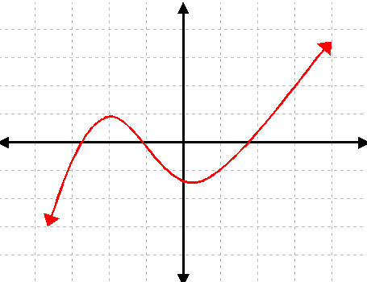
1. What is the domain of the function g(x)? g(x)

2. What is the range of g(x)?

3. On what interval(s) is g(x) increasing?

4. On what interval(s) is g(x) decreasing?

5. On what interval(s) is g(x) constant?

6. What is the y-intercept of g(x)?

7. What are the x-intercepts of g(x)?

8. What are the zeroes of g(x)?

PART C
1. What is the domain of the function H(x)?
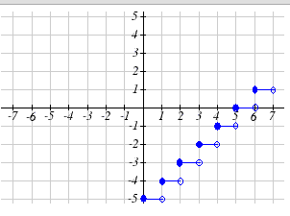

H(x)
2. What is the range of H(x)?

3. On what interval(s) is H(x) increasing?

4. On what interval(s) is H(x) decreasing?

5. On what interval(s) is H(x) constant?

6. What is the y-intercept of H(x)?

7. What are the x-intercepts of H(x)?

8. What are the zeroes of H(x)?

PART D
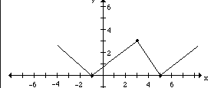
1. What is the domain of the function?

2. What is the range of the function?

3. On what interval(s) is the function increasing?

4. On what interval(s) is the function decreasing?

5. On what interval(s) is the function constant?

6. What is the y-intercept of the function?

7. What are the x-intercepts of the function?

8. What are the zeroes of the function?

PART E
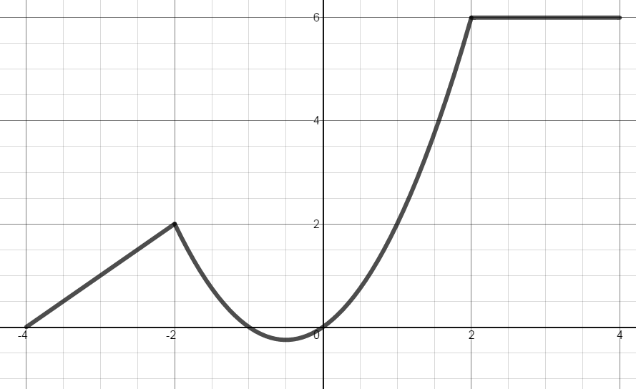
1. What is the domain of the function K(x)?

K(x)
2. What is the range of K(x)?

3. On what interval(s) is K(x) increasing?

4. On what interval(s) is K(x) decreasing?

5. On what interval(s) is K(x) constant?

6. What is the y-intercept of K(x)?

7. What are the x-intercepts of K(x)?

8. What are the zeroes of K(x)?

