NAME____________________________________DATE__________________

ALGEBRA II WORKSHEET: GRAPHING POLYNOMIAL FUNCTIONS

1-5. For each function, find the x-intercept(s), y-intercept, maximum number of extrema, and end behavior (use mathematical notation). Then graph the function using a broken curve. Show ALL work on a sheet of graph paper.

1.  2. 

3.  4. 

5. 

6-9. Find the equation of the polynomial function whose graph is shown. Leave your answer in factored form. Show your work on the same sheet of graph paper.

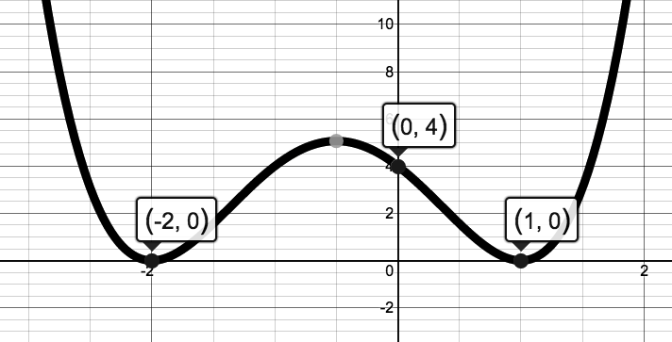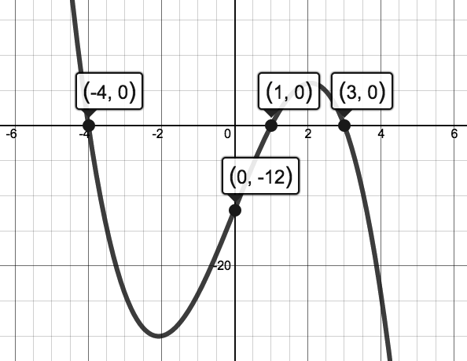6. 7.

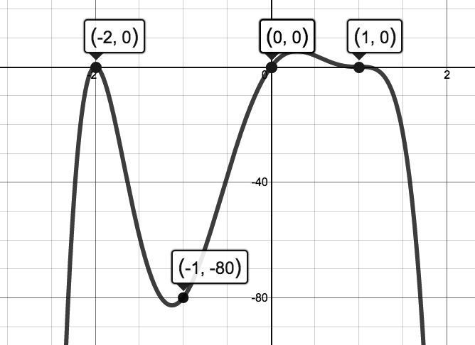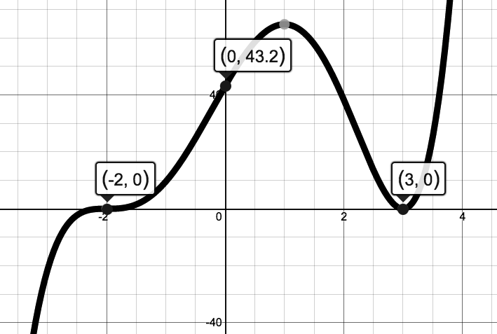8. 9.

Answers for 6-9.

6.  7. 

8.  9. 