NAME_____________________________________DATE_______________
FINDING EQUATIONS OF RATIONAL FUNCTIONS

Find the equation of each function. You may leave your final answers in factored form.

1. Vertical asymptotes: x = 2, x = -3; x-intercepts: (5, 0), (-8, 0)

2. No vertical asymptotes; horizontal asymptote: y = 0; y-intercept: (0, 5)

3. Vertical asymptote: x = -2; removable discontinuity at x = 4, x-intercept: (0, 0)

4. No horizontal asymptote, vertical asymptote: x = 3; removable discontinuity at x = 7.

5-7. Find the equation of each function given the graph.

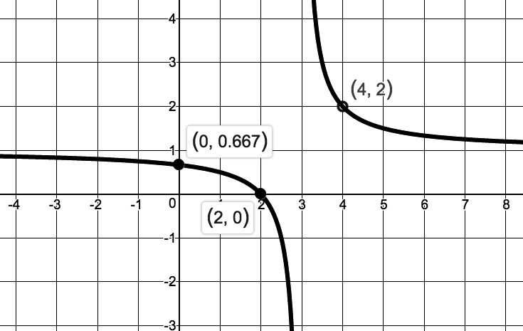
5.

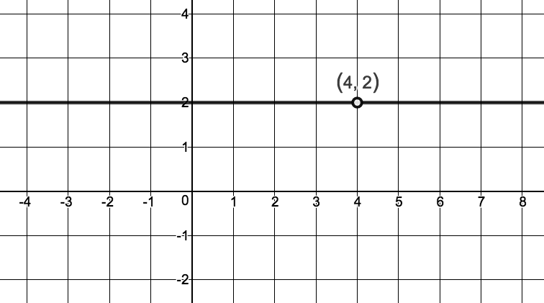
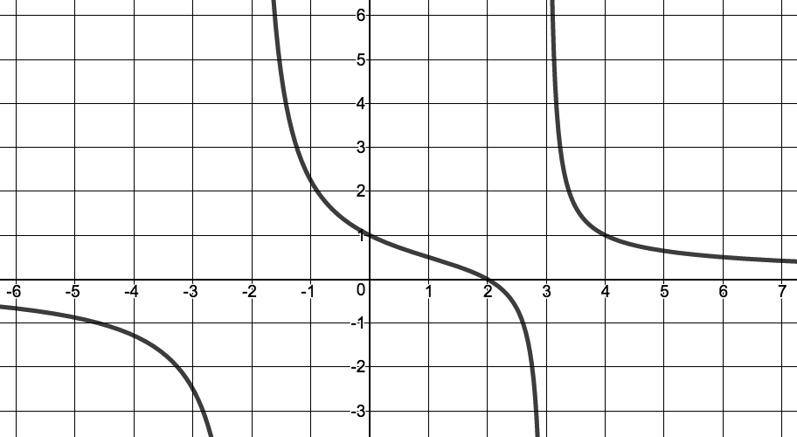
6. 7.

