NAME___________________________________________________DATE___________________________
ALGEBRA II WORKSHEET: FINDING QUADRATIC EQUATIONS

Find the equation of the function whose graph is shown. You may express your answer in any form.

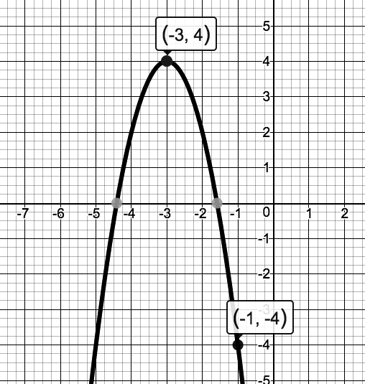
1. 2.
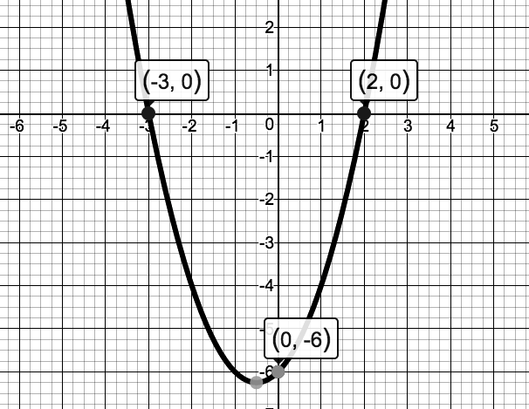

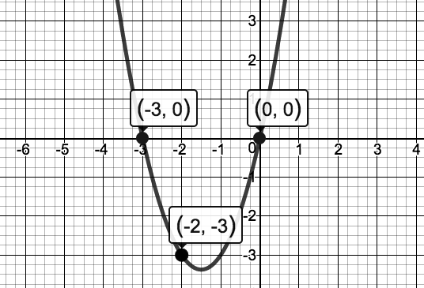
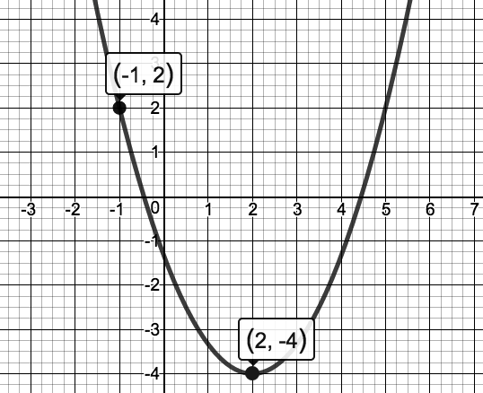
3. 4.

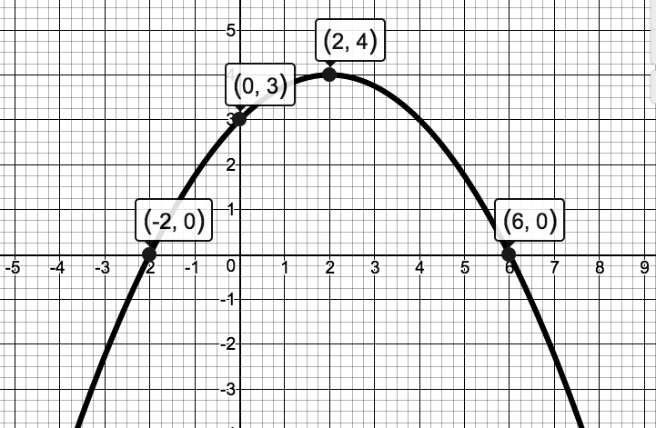
5

