NAME____________________________________DATE______________________
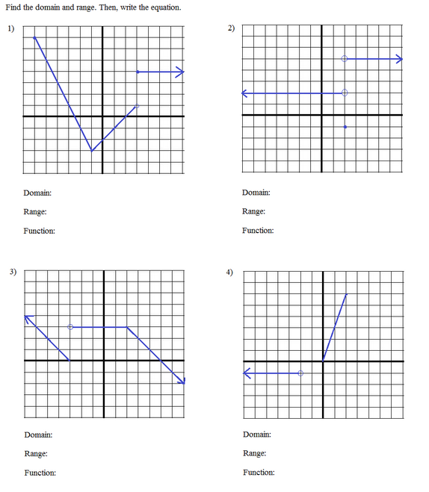
ALGEBRA II PRACTICE ON PIECEWISE FUNCTIONS

