NAME_____________________________________DATE______________________

ALGEBRA II WORKSHEET: APPLICATIONS OF QUADRATIC EQUATIONS

Show all work on a separate sheet of paper.

1. An in-ground swimming pool of length of 35 feet and a width of 23 feet is to be built with a walkway surrounding it. The total area of the pool and walkway together is 1200 square feet. To the nearest inch, how wide does the walkway need to be?

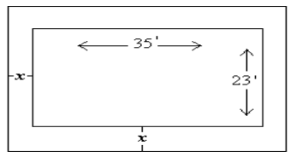

a) Write an expression that represents the length of the outer edge of the walkway.

b) Write an expression that represents the width of the outer edge of the walkway.

c) Write an expression expressing the total area of the pool and walkway.

d) Answer the question posed in the original prompt.

2. A rectangle has a perimeter of 23 cm and an area of 33 cm2. Find the dimensions of this rectangle.

a) Sketch a diagram that represents this situation. Label the length and the width of the rectangle.

b) Using your labels for length and width, write an equation to represent the perimeter of the rectangle.

c) Using your labels for length and width, write an equation to represent the area of the rectangle.

d) Use the equations from parts (b) and (c), find the dimensions of the rectangle.

3. A farmer has 1200 m of fencing. He wants to enclose a rectangular field bordering a river, with no fencing needed along the river. Find the dimensions of the field if the area of the field is 180,000 square meters.

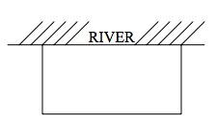

4. Find two consecutive odd integers whose product is 143.

5. Find two consecutive integers such that the sum of their squares is 145.

6. Find a rational number such that the sum of the number and its reciprocal is .

7. An electronics store is selling car chargers for cell phones. The revenue function is , where x represents the selling price of each car charger in dollars and R represents the revenue the store earns from selling the chargers. The cost function for purchasing the chargers can be modeled by the function , where x represents the selling price of the chargers and C represents the total cost for the business in dollars.

a. The point (10, 10,000) is a point on the cost function. Explain the significance of the

point in context of the situation.

b. How many chargers can the business buy if the selling price is $10?

c. What is the revenue the business can earn at a selling price of $20?

d) At what selling price will the business break even; that is, at what price will the revenue equal the cost?

8. An arrow is fired from ground level with an initial upward velocity of 160 feet per second. The arrow’s height can be expressed as a function of time by the equation , where t is in seconds and h is in feet.

a. What is the arrow’s height after 3 seconds?

b. When will the arrow strike the ground?

c. What is the domain of the function?

d. What is the implied domain of the function (within the context of the problem)?

9. Alex Rodriguez of the New York Yankees hits a pop fly whose path flows the equation , where t represents the time in seconds and h represents the height of the ball in feet. In how many seconds will Dustin Pedroia catch the ball at a height of 6 feet above the ground?