STATION #1

Simplify each expression completely, leaving only positive exponents. For a review on laws of exponents, go to <https://www.mathsisfun.com/algebra/exponent-laws.html>; for help with negative exponents, go to <http://www.purplemath.com/modules/exponent2.htm>.

1.  2. 

3.  4. 

5.  6. 

7.  8. 

9.  10. 

11.  12. 

13.  14. 

15.  16. 

STATION #6

1-8. Simplify each expression completely, leaving your answer as a fraction in simplest form. For help with fraction operations, go to <http://cstl.syr.edu/fipse/fracunit/opfrac/opfrac.htm>.

1.  2. 
2.  4. 
3.  6. 
4.  8. 
5. Pam bought  pounds of apples for $3.00. How much will 4 pounds of apples cost?
6. Sarah wants to run 20 miles per week. On Monday, she ran  miles. On Tuesday, she ran  miles. On Wednesday and Thursday, she did not run at all. On Friday, she ran  miles. How many miles per day must Sarah run on Saturday and Sunday to reach her goal?
7. Match the equivalent expressions or statements.

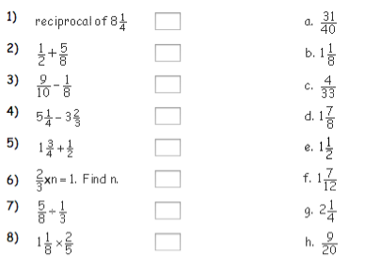

STATION #2

1-18. Simplify each expression completely. Leave answers in simplest radical form. For help with radicals, please visit <http://www.mathwarehouse.com/algebra/radicals/how-to-simplify-radicals-video-tutorial-with-examples.php>.

1.  2. 

3.  4. 

5.  6. 

7.  8. 

9.  10. 

11.  12. 

13.  14. 

15.  16. 

17.  18. 

19. The value of  is between which two whole numbers?

20. The value of  is between which two whole numbers?

21. What is the approximate value of ? What is the approximate value of ?

22. What is the approximate value of , to the nearest whole number?

STATION #3

1-6. Find each sum or difference. For help with adding and subtracting polynomials, please visit <https://www.mathsisfun.com/algebra/polynomials-adding-subtracting.html>.

1.  2. 

3.  4. 

5.  6. 

7-13. Multiply. For help with multiplying polynomials, please visit <http://www.mathsisfun.com/algebra/polynomials-multiplying.html>.

7.  8. 

9.  10. 

11.  12. 

13.  14. 

15. Since 1970, the number of males enrolled in colleges (in thousands) can be modeled by the function , and the number of females enrolled in colleges (in thousands) can be modeled by , where t is the number of years since 1970.

a. Write a model for the total number of people attending college.

b. According to the model, how many males attended college in 2008?

c. According to your model, how many people attended college in 2008?

d. According to these models, did more males or females attend college in 1970? Explain.

16. The graph of the product of  and  is shown. What is the equation that corresponds to that graph? Write your answer in expanded form.

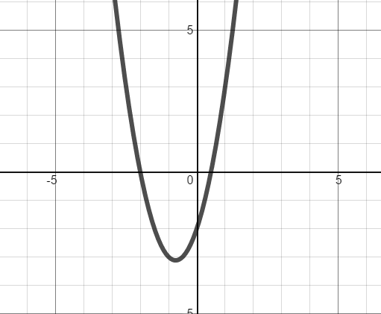

STATION #4

1-19. Factor each polynomial completely. If the polynomial cannot be factored, write “Prime”. For help with factoring by grouping, please visit <http://www.purplemath.com/modules/simpfact3.htm>. For help with factoring trinomials, please visit <http://www.regentsprep.org/regents/math/algebra/AV6/Lgrouping.htm>. For help with factoring binomials, please visit <http://www.purplemath.com/modules/specfact.htm>.

1.  2. 

3.  4. 

5.  6. 

7.  8. 

9.  10. 

11.  12. 

13.  14. 

15.  16. 

17.  18. 

19.  20. 

20. The polynomial  is factorable. Find one possible value of b.

21. The polynomial  is factorable. Find one possible value of c.

STATION #5

1-2. MULTIPLE CHOICE. Circle the letter corresponding to the correct answer.

1. Which of these equations is NOT quadratic?

a.  b. 

c.  d. 

2. What value would be needed to complete the square for ?

a. 13 b.  c.  d. 

3-4. Find all solutions to each equation using the Zero Product Property.

3.  4. 

5-6. Solve each equation by completing the square. Write exact answers, no decimals.

5.  6. 

7-8. Solve each equation using the Quadratic Formula. Write exact answers, no decimals.

7.  8. 

9-10. Solve each equation by extracting roots (taking square roots). Write exact answers, no decimals.

9.  10. 

11. The length of a rectangular pool filter intake is three centimeters less than twice its width. If the area of the intake is 350 square cm, find its dimensions. Use any method to solve the equation and round your answer to one decimal place if necessary.