NAME___________________________________DATE______________________

ALGEBRA II PRACTICE ON QUADRATIC FUNCTIONS

1-4. Find the vertex of the graph of each function.

1.  2. 

3.  4. 

5-8. Find the axis of symmetry for each of the functions in Questions 1-4.

9-12. Find the domain and range of each function.

9.  10. 

11.  12. 

13. Find the intersection point(s) of the graphs of  and .

14. Sketch the graph of . It would help to find the vertex and intercepts first and graph the corresponding equation.

15. The graph of a quadratic function f(x) and the equation of g(x) are given. Which function has the greater maximum value? Show work or explain how you found your answer.

Graph of f(x) 

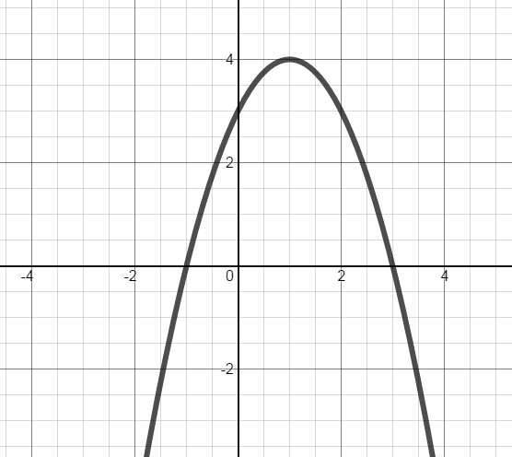

16. The graph of a quadratic function in the form  is shown.

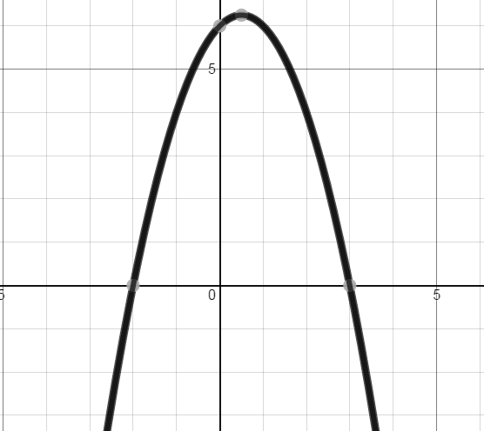

a. Is the value of “a” positive or negative? Explain.

b. What are the values of “m” and “n”?

17. If the equation that represents this graph is written in the form ,

a. Is “h” positive or negative? Explain.

b. Is “k” positive or negative? Explain.

18-19. Find the x- and y-intercepts for each function, if they exist.

18.  19. 

20. A ball is thrown from the top of a school such that its flight can be modeled by the equation , in which t represents the time in seconds and h represents the height of the ball in feet.

a. What is the height of the ball after two seconds?

b. In how many seconds will the ball hit the ground?

c. What is the height of the school building?

d. In how many seconds will the ball reach its maximum height?

e. What is the maximum height of the ball?

f. A second person throws a ball off of the same roof such that its flight can be modeled by the equation .

* Will this ball travel higher than the first ball? Explain.
* Which ball will stay in the air longer? Explain.