NAME____________________________________________DATE________________

ALGEBRA II WORKSHEET: RATIONAL EXPRESSIONS AND EQUATIONS

Complete all examples on looseleaf.

1-4. Simplify each fraction completely. HINT: Only Factors Can Cancel.

1.  2. 

3.  4. 

5-8. Multiply or divide the given fractions. HINTS: Factor first; change division to multiplication by the reciprocal of the divisor.

5.  6. 

7.  8. 

9-12. Simplify completely. Add or subtract. HINT: Find a common denominator.

9.  10. 

11.  12. 

13-15. Solve each equation. HINT: Only here can you clear the denominators out by multiplying by the LCD.

13.  14. 

15. 

16-17. Solve each example using the five-step plan.

16. A farmer can milk his cows in 40 minutes, and his son can milk the cows in 1 hour. How long would it take the two of them working together to complete the job?

17. Kinan can paint a room in 9 hours working alone. Julia can paint the room alone in 7 hours. How long would it take the two of them to paint three rooms working together?

18. Delaney is planning to run five miles. She runs the first three at an average speed of 7 mph. How fast must she run the last two miles in order to run an average of 7.5 mph for the entire run?

19. Shane wants to drive to New York City, which is 180 miles away. For 1.2 hours, he drives at an average speed of 50 mph. How fast must he drive the remainder of the trip to arrive in New York in three hours or less?

20-22. Graph each equation on graph paper. Be sure to find all asymptotes and intercepts and create a table.

20.  21.  22. 

KEY

1.  2.  3. 

4.  5.  6. 

7.  8.  9. 

10.  11. 

12.  13. x = 3 14.  15. w = -8

16. 24 minutes 17. 11.81 hours 18. 8.4 mph 19. 66.7 mph

20. 21.

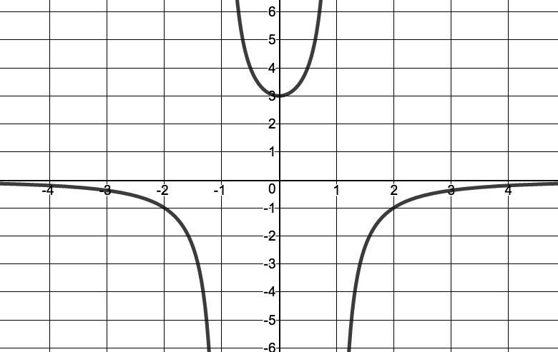

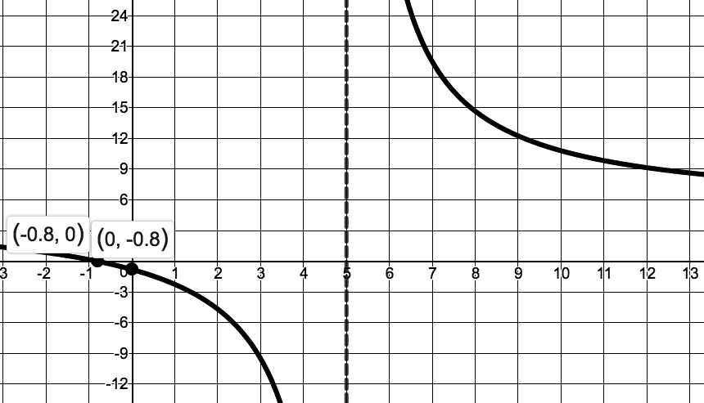

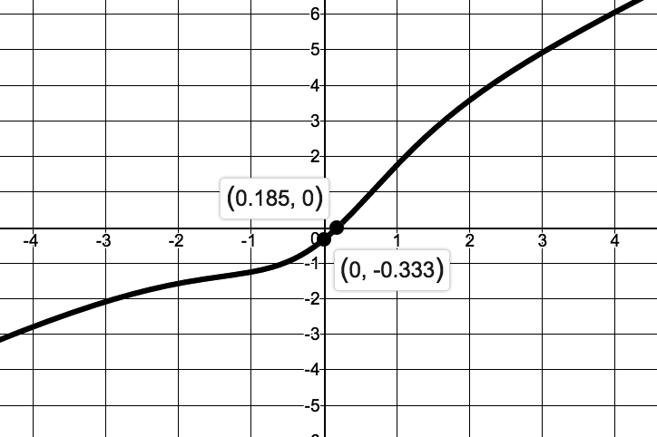22.