>> Relation:

>> Function:

Domain:

Range:

1. ***Relations as a MAPPING or CORRESPONDENCE Representation***

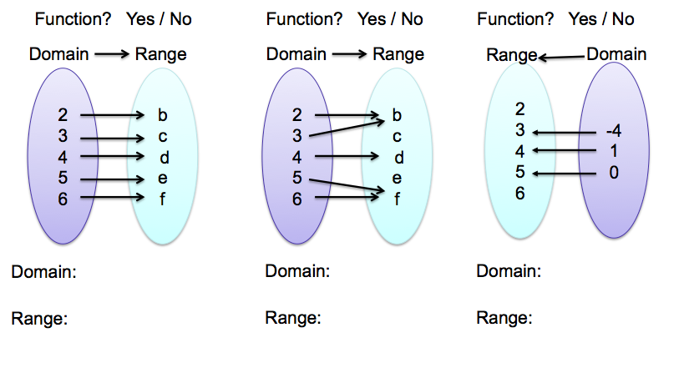

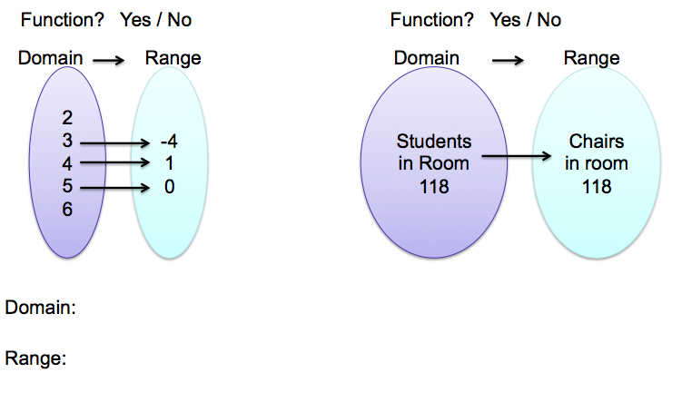

1. ***Relations as a TABLE OF VALUES Representation***

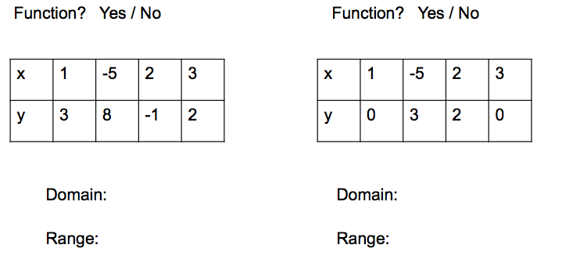

***C. Relations as an ORDERED PAIRS Representation***

Function? YES / NO Function? YES / NO Function? YES / NO

{ (1,3), (-5,8), (2, 3), (3,2) } { (1,3), (2, 9), (-5, 3), (1, 6) } { (1, 4), (2, 8), (1, 4), (4, 6) }

Domain: Domain: Domain:

Range: Range: Range:

1. ***. Relations as a: GRAPHICAL Representation***

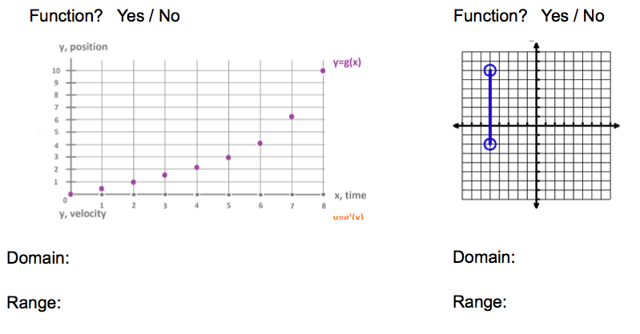

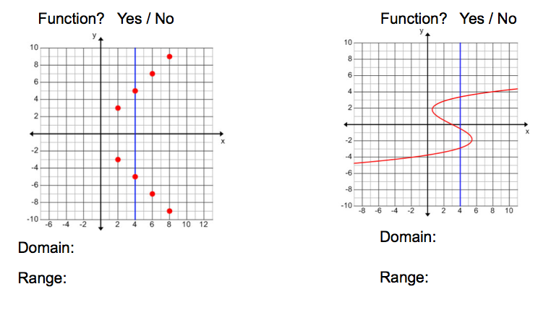

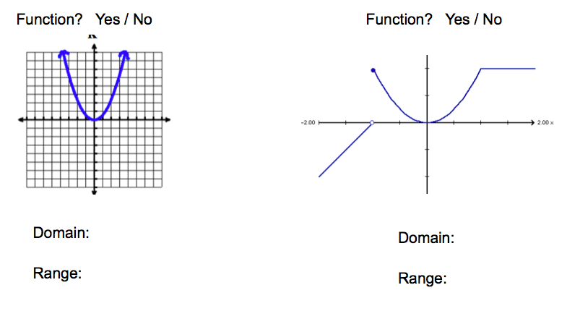

***E. Relations as a VERBAL (WORDS) Representation***

E.1. It snowed for five hours. The snow accumulated at a rate of one inch per hours.

Independent Variable: Domain:

Dependent Variable: Range:

Function or Not?

E.2. The cost for a field trip is based on the number of people who attend. The bus can accommodate 32 people. The cost C is represented buy the linear equation C = 20x+250

Independent Variable: Domain:

Dependent Variable: Range:

Function or Not?

E.3. Given a domain of {5,7,9}, the output is the input divided by 3. What is the range?

Independent Variable: Domain:

Dependent Variable: Range:

Function or Not?

***F. Relations as Equations***

F.1. Given the equation 

Independent Variable: Domain:

Dependent Variable: Range:

Function or Not?

F.2. Given the equation 

Independent Variable: Domain:

Dependent Variable: Range:

Function or Not?

F.3. Given the equation 

Independent Variable: Domain:

Dependent Variable: Range:

Function or Not?

Can you think of another equation that is a function? Not a function?