Create a graph 1

Draw a function that has the following characteristics:

* Range: 
* Zeros: *x* = -4, -1, 3
* y-intercept: ( 0, 5)
* Relative maximum: f(x) = 5
* Relative minimum : f(x) = -4
* f(5) is undefined
* f(-2) = -1

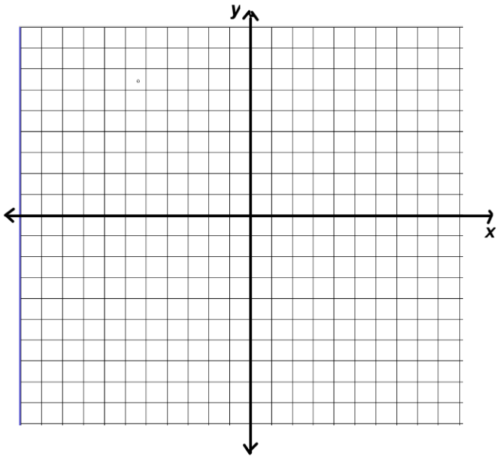

Create a graph 2

Draw a function that has the following characteristics:

* Domain: 
* Range: 
* Zeros: *x* = -3,0 2
* y-intercept: ( 0, 0)
* Increasing: 

* Decreasing: 
* f( *x* ) < 0 when *x* > 4



Create a graph 3

Draw a function that has the following characteristics:

* Domain: 
* Range: 
* Zeros: *x* = 2

* Decreasing: 
* Absolute maximum when x = 0
* f(-3)= 1 is a relative minimum
* f(x) is constant on 



Create a graph 4

Draw a function that has the following characteristics:

* Domain: 
* Zeros: *x* = 0,6
* f(-50) = 2
* relative maximum when x = 3
* f(x) = 0 is a relative minimum
* constant on 
* f(x) > 0 on 



Create a graph 5

Draw a function that has the following characteristics:

* Domain: 
* Zeros: None
* F(0) = -3
* F(x) = -2 is a Relative maximum
* F(x) = -1 is the absolute maximum
* No absolute minimum

* Increasing: 
* F(x) < 0 on the entire domain



Create a graph 6

Draw a function that has the following characteristics:

* Zeros: x = - 4, 6
* f(0) = 3
* f(-1 ) is undefined
* f(x) = 5 does not exist
* Increasing 
* Decreasing 
* No extrema

