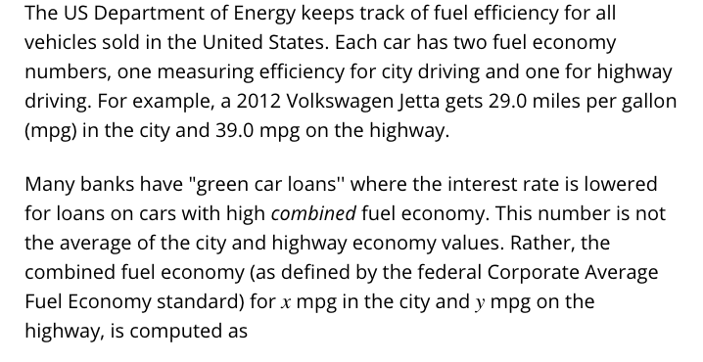

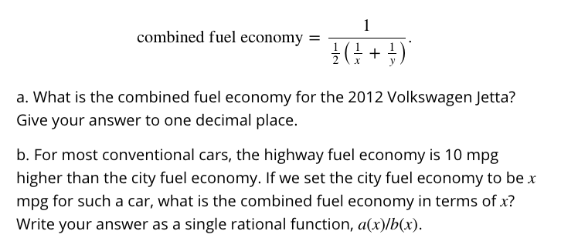

c. Look up the city and highway fuel economy for one car that interests you. Find its combined fuel economy using both the formula given above and your answer from Part b. Be sure to state which car you chose.

