NAME_____________________________________DATE____________________

ALGEBRA II WORKSHEET: GRAPHING QUADRATIC EQUATIONS

For this activity, we are going to build a quadratic function from linear functions and look at various forms of quadratic equations.

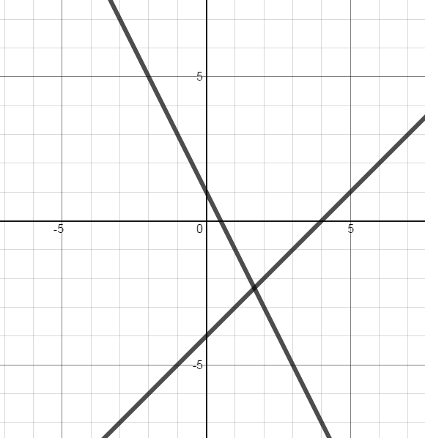Look at the given graph. The equations shown are y = x – 4 and y = -2x + 1. On the graph, label y = x – 4 as  and y = -2x + 1 as . Explain how you knew which line was which in complete sentences.

Next, complete the table. Find the values of y for each function for each value of x, then multiply

corresponding values of y to find .

|  |  |  |  |  |  |  |  |  |  |
| --- | --- | --- | --- | --- | --- | --- | --- | --- | --- |
| x | -3 | -2 | -1 | 0 | 1 | 2 | 3 | 4 | 5 |
|  |  |  |  |  |  |  |  |  |  |
|  |  |  |  |  |  |  |  |  |  |
|  |  |  |  |  |  |  |  |  |  |

Plot the points (x, ) on the grid above. Connect the points from left to right. Look for any conclusions you can draw from your new graph (intercepts, orientation of the graph, intervals on which y is positive or negative, for example) and be prepared to discuss findings with the class. By the way, the name of the graph is a *parabola*, and the highest or lowest point on this type of graph is called the *vertex*.

Write an equation describing the function you just plotted.

Now multiply . On your Chromebook, go to [www.desmos.com/calculator](http://www.desmos.com/calculator). In the expression bar, type in your product. For exponents, use the carat key (Shift 6). A graph should appear on screen. Does this graph match your graph from the first page?

On the Desmos page, type “Enter”. In the new expression bar, type , again using “Shift 6” for the exponent. You will asked if want to add a slider. Click on “All”.

Before we go to the next part of our activity, take a minute to play with the sliders by dragging them left and right. Describe how the graph changes when each slider is moved. Just move one slider at a time. To begin, what is the effect on the graph when the slider value is positive or negative. Then consider what happens when the slider value is increased or decreased. Ideally, determine how the specific slider values reveal themselves in the graph.

a

b

c

Now, move the sliders so that the graph matches the one you plotted previously. Write the equation of this function with the correct values for a, b, and c below.

Focus on the values for b and c. Where do those two numbers reveal themselves in the graph?

Congratulations! We have now graphed a quadratic equation in three different forms. They are:

Factored form: 

Standard form: 

Vertex form: 

Vocabulary you will need to understand for this unit. Check the terms you already understand.

* Quadratic equation
* Quadratic term
* Linear term
* Constant term
* Parabola
* Factored form
* Vertex form
* Standard form
* Concave up
* Concave down
* Vertex
* X-intercept
* Y-intercept
* Axis (or line) of symmetry